File: your_dataset2.csv
Country,Year,GDP,Life Expectancy,Population,CO2 Emissions (t per capita)
India,2015,1471693224223.705,65.9696786990257,1161945137.7211819,7.456689870524991
India,2016,1202336274218.452,71.93931382948146,205884672.71492007,16.14284112470377
India,2017,686376609199.427,81.71151260521138,1083420229.3223538,4.374955789916362
India,2018,513805292809.006,77.94015142600635,992531707.9481878,14.715639776799252
India,2019,2428175866714.8643,61.62898233814999,508267362.67653894,2.7594466607400294
India,2020,2657758564688.984,73.71255879020627,469948254.54518235,1.7393878305774608
China,2015,3325450005778.85,70.76796072610638,1380054131.2137349,5.220077794474258
China,2016,13606643174414.63,76.75563153723178,340316186.1494355,14.700218797931262
China,2017,7671771088025.4375,73.91072827305875,890606297.9576436,10.94760633945779
China,2018,2260650516060.962,78.37665490296324,455884290.3107128,4.1371109527971575
China,2019,1295115260317.8965,72.99964475014131,951814462.9607725,0.823462664093195
China,2020,10485814636835.979,64.98290705435464,906790178.6691353,3.900145365597333
United States,2015,801404022312.9148,80.42300837692996,605175966.1610669,19.349768971351555
United States,2016,19290589553240.43,78.76620802028192,419283959.9767241,8.009405707737542
United States,2017,17097165094578.709,66.9722841134381,245594917.89366856,11.357624617937828
United States,2018,18755018096135.23,75.31265552684941,802385026.4242173,2.3949416285299865
United States,2019,12492640920633.81,81.78118470229379,204716781.1787684,10.607428221092867
United States,2020,17608774902595.133,76.29690959059249,978851879.9834225,14.198439637748631
Brazil,2015,17181481388214.64,75.48047290636052,669101622.4313821,2.4077661326945288
Brazil,2016,10086509564778.23,70.41637895717244,250750599.1749211,8.960107160140474
Brazil,2017,8270842320748.782,73.54870215714877,892780174.7060249,1.3834281905548682
Brazil,2018,7804945985216.188,73.7689181457132,709359399.4263219,17.201551903172284
Brazil,2019,13344525816569.428,63.58455739579145,108090558.88659748,13.027175925023155
Brazil,2020,1016970555561.6254,72.8870627880162,1316920035.580691,11.72174646857964
Germany,2015,7342842744765.534,62.57547436140733,208758438.05344185,15.349457318490709
Germany,2016,12555252234667.09,62.22469887470139,126908460.49984643,14.16889806345284
Germany,2017,1918878624101.7737,78.08092130438783,991676695.7475297,2.0863012225170454
Germany,2018,2154335424661.2424,81.70607072702586,530236406.1010072,7.727521867804373
Germany,2019,16349591561521.3,80.83946870244489,1380541478.7137907,15.190874612549361
Germany,2020,7837061917852.857,61.837015767370715,1090234213.139137,11.388882869848198
South Africa,2015,12085548949366.635,68.37959884588247,1358181012.9622984,16.92131900114632
South Africa,2016,16847409741867.188,70.31124951548935,586599108.2493546,5.831437902648772
South Africa,2017,1599322184693.0786,79.02389227761117,1139932402.6908078,19.994494629079547
South Africa,2018,19934418322941.156,72.2194975232578,1078892507.1009097,18.922931732707347
South Africa,2019,17068124118209.523,65.44165823835034,636256348.08103,3.018608595454152
South Africa,2020,19103995031545.086,73.33584195791936,327813499.6498132,13.598163345914207
Australia,2015,12744057595072.701,61.798698702875186,1224274287.5084202,18.457011810370357
Australia,2016,1691020217169.843,66.09130825923849,1130619778.9123552,15.091063962481337
Australia,2017,4098159877449.358,64.60568511340763,524956222.880021,9.948198211224916
Australia,2018,12555968044840.771,68.116100070535,652923255.4250755,15.075683293608252
Australia,2019,1215322456366.6592,65.55361277556845,1001555924.3795279,17.95653333490039
Australia,2020,10477710121255.49,71.70649667583695,158969095.76228872,9.224541153057366

CODE:
import pandas as pd
import matplotlib.pyplot as plt
import seaborn as sns
import plotly.express as px
# Load dataset
df = pd.read_csv('your_dataset2.csv')
# Basic exploration
df.info()
df.describe()
df.head()
OUTPUT:

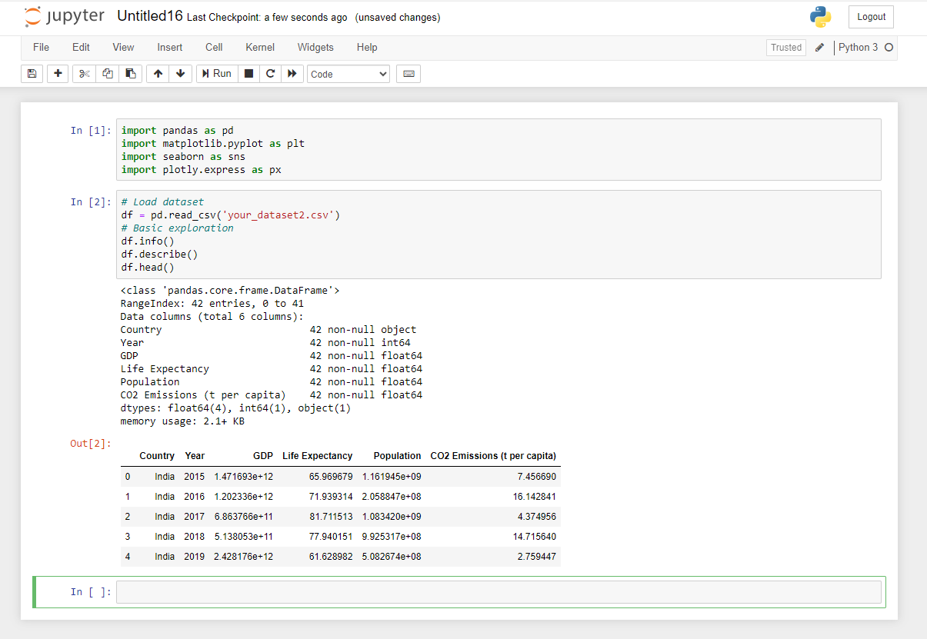

CODE:
import pandas as pd
import matplotlib.pyplot as plt
import seaborn as sns
import plotly.express as px
# Load dataset
df = pd.read_csv('your_dataset2.csv')
# Handling missing data
df.ffill(inplace=True)
# Convert 'Year' column to datetime
df['Year'] = pd.to_datetime(df['Year'], format='%Y')
# Normalize GDP column
df['normalized_gdp'] = (df['GDP'] - df['GDP'].min()) / (
df['GDP'].max() - df['GDP'].min()
)
print(df.head())

OUTPUT:
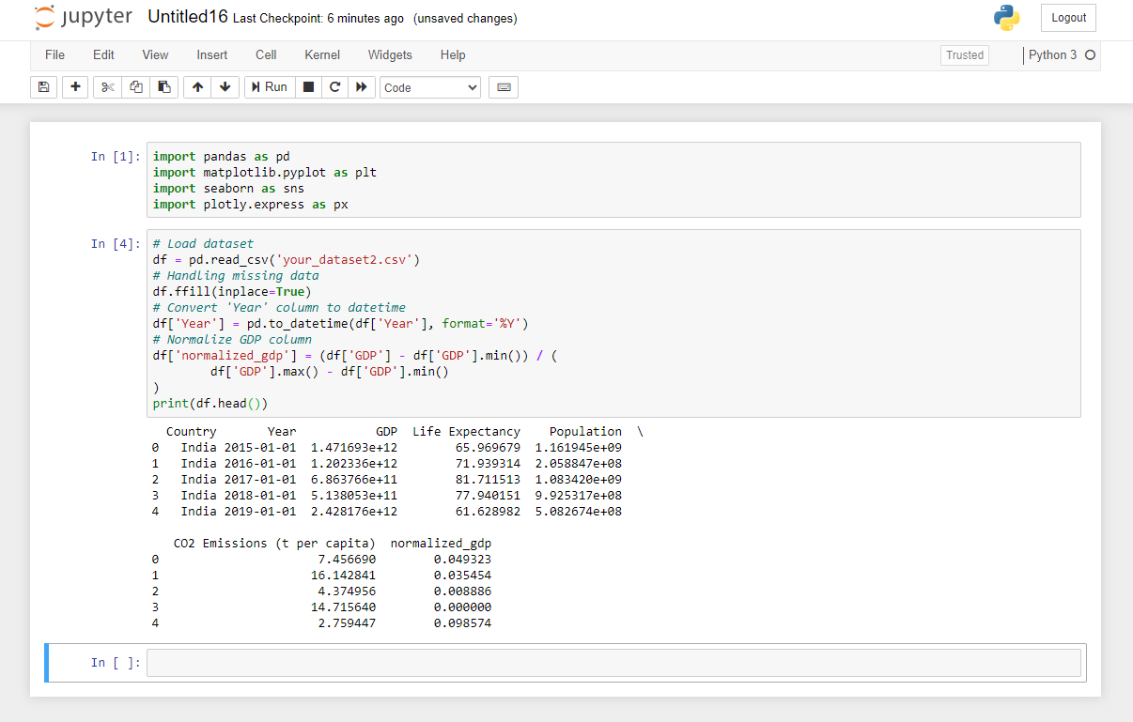

CODE:
import pandas as pd
import matplotlib.pyplot as plt
import seaborn as sns
print(sns.__version__)
import plotly.express as px
df = pd.read_csv("your_dataset2.csv")
sns.distplot(df['Life Expectancy'], kde=False) # histogram only
# Box plot
sns.boxplot(x='Country', y='Life Expectancy', data=df)
plt.plot(df[df['Country'] == 'India']['Year'], df[df['Country'] == 'India']['GDP'])
plt.title("India's GDP over time")
plt.xlabel('Year')
plt.ylabel('GDP')
plt.show()

OUTPUT:
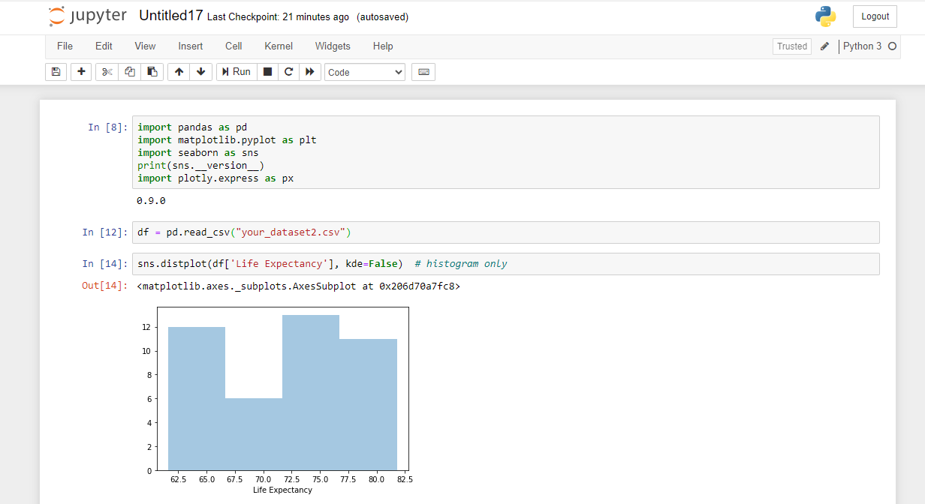
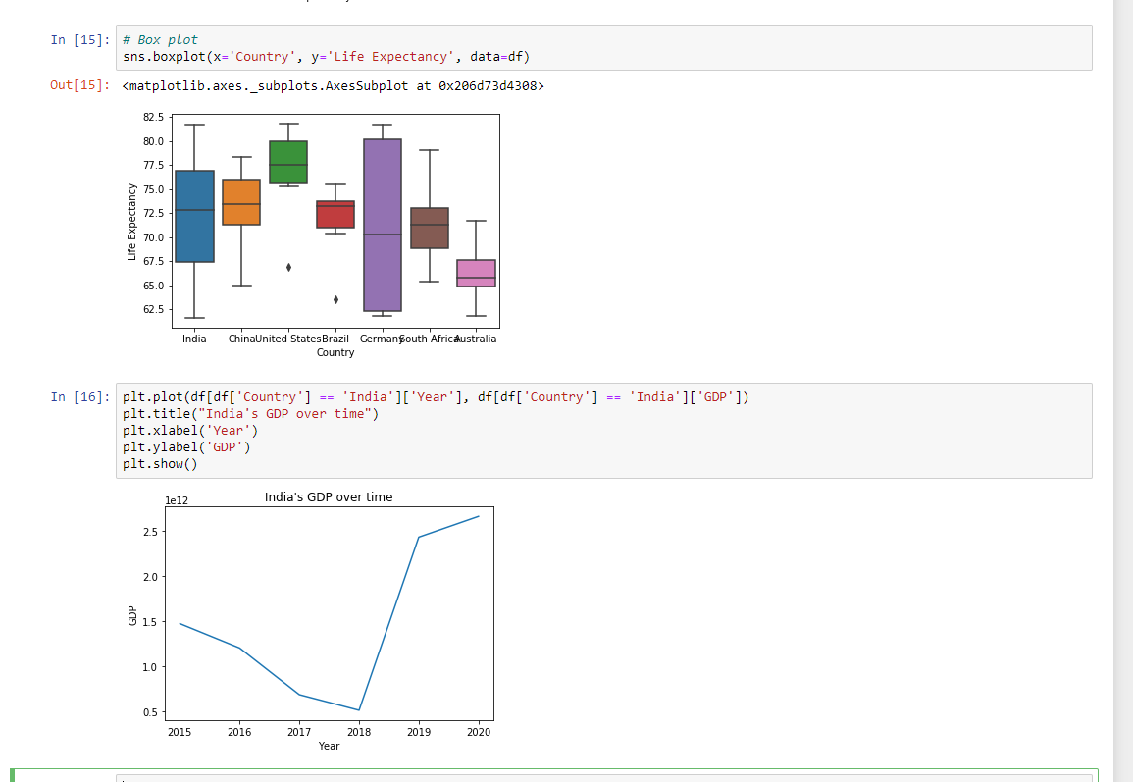

CODE:
import pandas as pd
import matplotlib.pyplot as plt
import seaborn as sns
import plotly.express as px
df = pd.read_csv("your_dataset2.csv")
# Heatmap
corr = df.corr(numeric_only=True)
sns.heatmap(corr, annot=True, cmap='coolwarm')

# Pairplot
sns.pairplot(df[['GDP', 'Life Expectancy', 'Population']])

# Plotly: Interactive GDP vs Life Expectancy
fig = px.scatter(df, x='GDP', y='Life Expectancy', hover_name='Country', size='Population')
fig.show()
#Heatmap

corr = df.corr(numeric_only=True)
sns.heatmap(corr, annot=True, cmap='coolwarm')
plt.show()
OUTPUT:
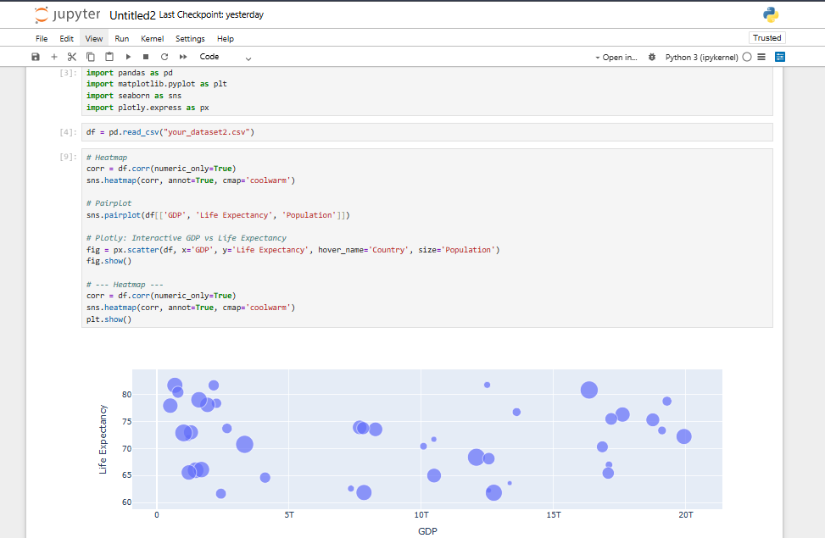
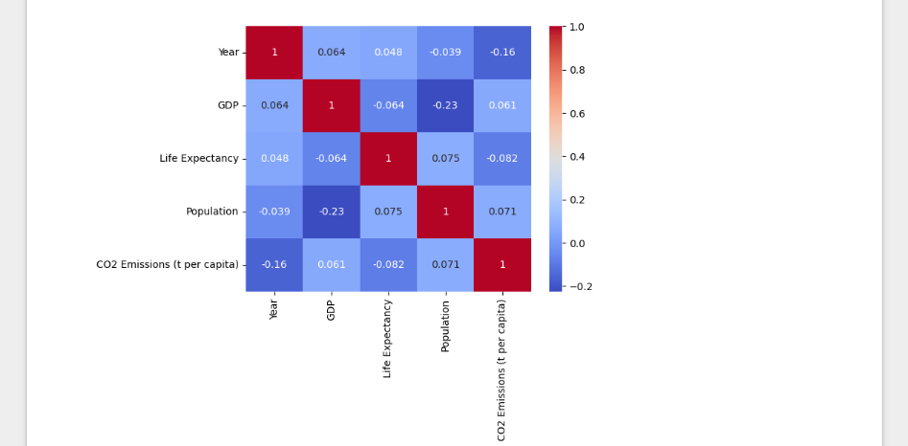

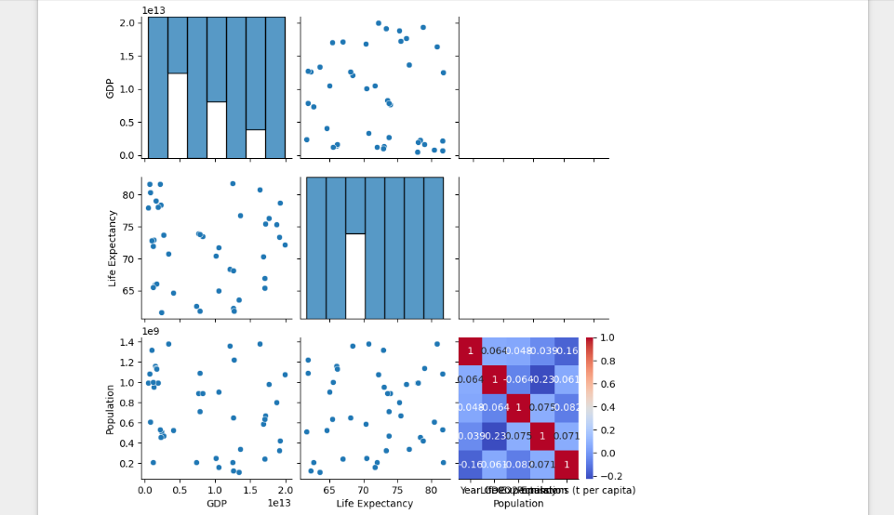

CODE:
from plotly.subplots import make_subplots
import plotly.graph_objects as go
df = pd.read_csv("your_dataset2.csv")
fig = make_subplots(rows=1, cols=2, subplot_titles=("GDP", "Life Expectancy"))

fig.add_trace(go.Box(y=df['GDP'], name='GDP'), row=1, col=1)
fig.add_trace(go.Box(y=df['Life Expectancy'], name='Life Expectancy'), row=1, col=2)

fig.update_layout(title_text="Dashboard: GDP vs Life Expectancy")
fig.show()

OUTPUT:
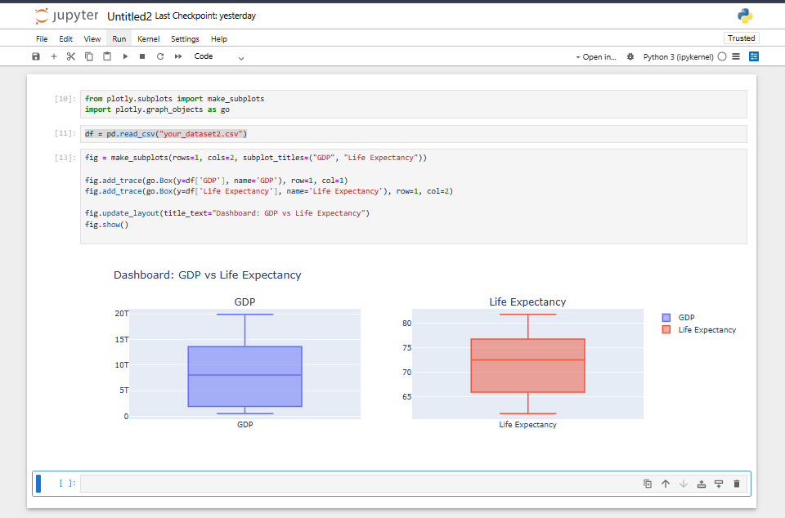

CODE:
from plotly.subplots import make_subplots
import plotly.graph_objects as go
df = pd.read_csv("your_dataset2.csv")
fig = make_subplots(rows=1, cols=2, subplot_titles=("GDP", "Life Expectancy"))

fig.add_trace(go.Box(y=df['GDP'], name='GDP'), row=1, col=1)
fig.add_trace(go.Box(y=df['Life Expectancy'], name='Life Expectancy'), row=1, col=2)

fig.update_layout(title_text="Dashboard: GDP vs Life Expectancy")
fig.show()

plt.savefig('gdp_trend.png') # Save matplotlib chart
fig.write_html("interactive_gdp_chart.html") # Save interactive Plotly chart

OUTPUT:
